SELENOPHILE APP FORMED BY NAMRA IRFAN
NAMRA IRFAN
REGISTRATION NUMBER:251301014
NAMRA IRFAN
ICT LAB SEMESTER PROJECT SUBMITTED TO SIR AHSAN FIAZ

KEY FEATURES OF THE APP
- FIRST YOU WILL CREATE ACCOUNT ON THE APP
- THEN LOGIN YOUR ACCOUNT
- THEN YOU CAN VIEW STORIES AND POSTS OF OTHER PEOPLE
- YOU CAN LIKE AND COMMENT
- YOU CAN EXPLORE
- YOU CAN MESSAGE YOU FRIENDS
- YOU CAN VIEW YOUR PROFILE
- YOU CAN CHANGE SETTINGS OF YOUR PROFILE
- YOU CAN EDIT BIO OF YOU PROFILE
- YOU CAN LOGOUT
- IT CHANGES COLOUR THEME ON EVERY CLICK
NOTE:
THE APP IS MADE UP OF HTML+CSS+JS THESE ALL ARE USED IN IT TO MAKE THE APP ATTRACTIVE USE ABLE . THE APP IS MADE UP ON NOTEPAD BY USING THESE LANGUAGES IN ONE SINGLE CODE. THE CODE IS SHOEN BELOW:
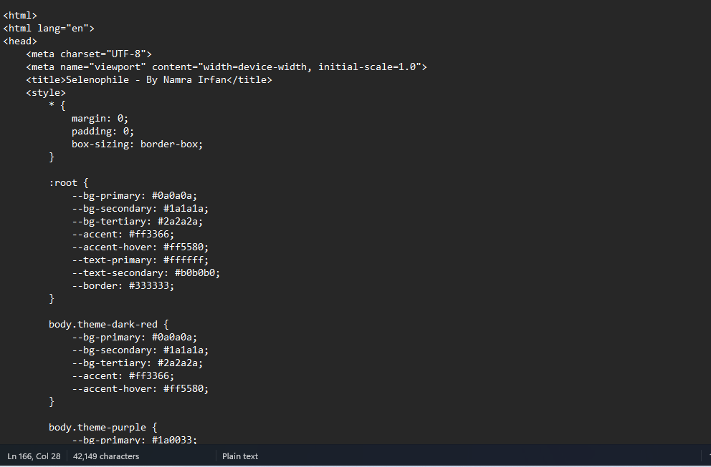
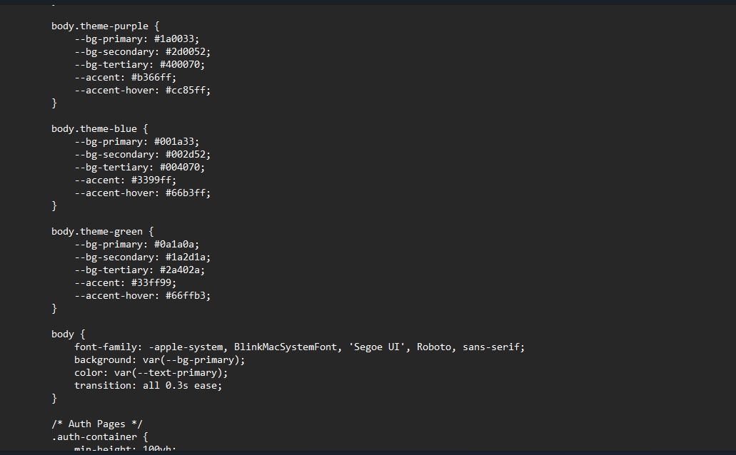
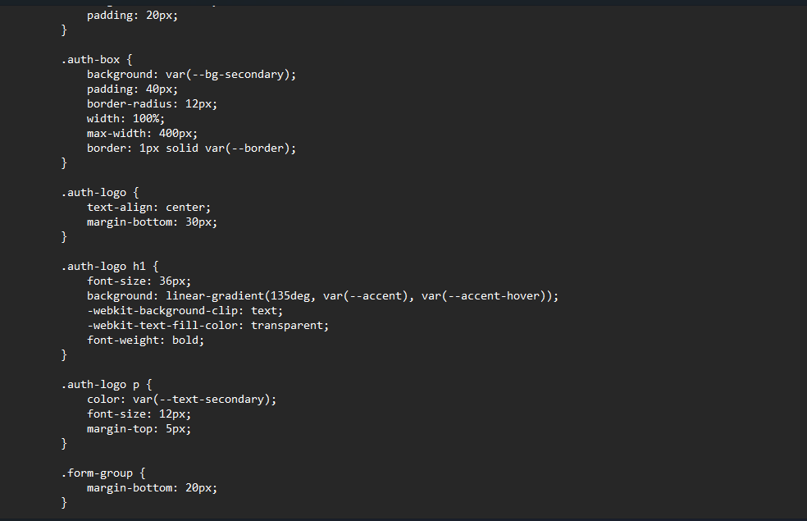
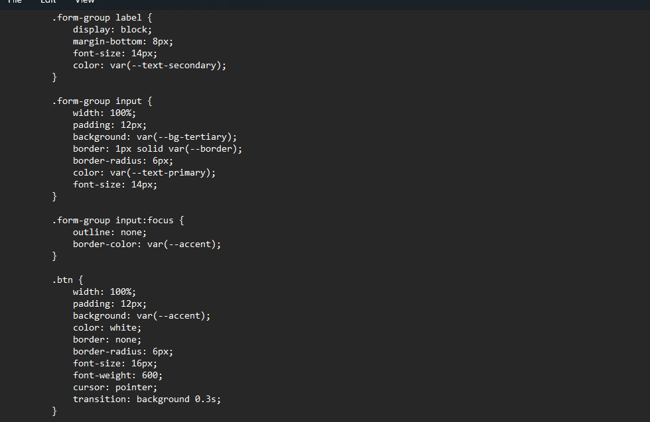

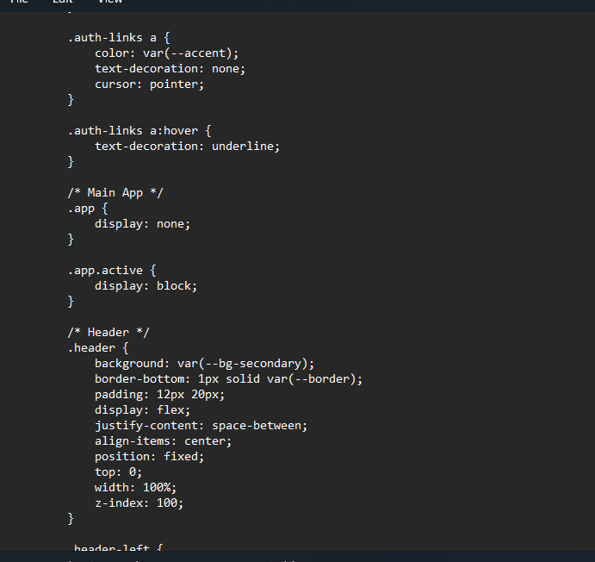
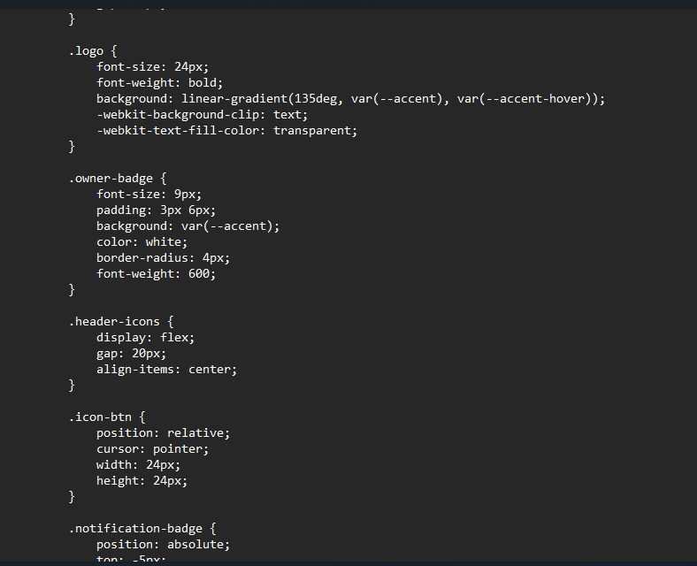
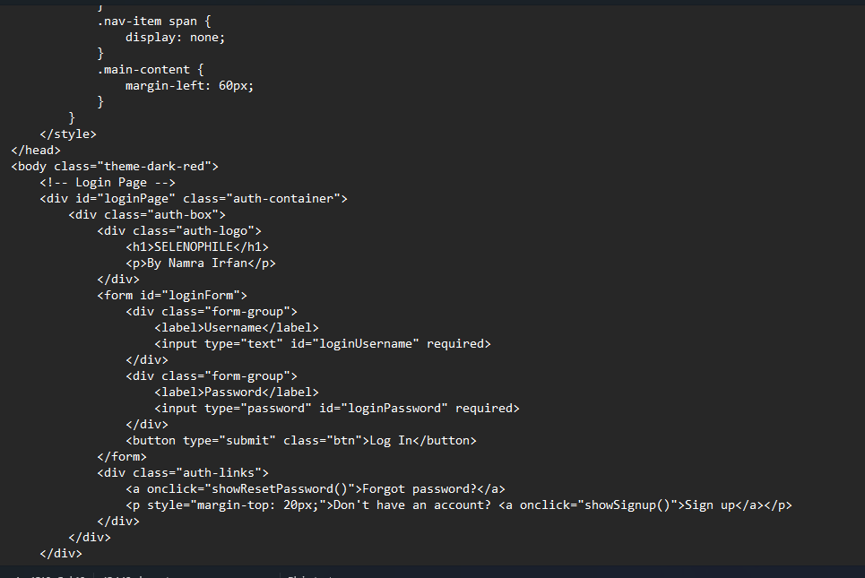
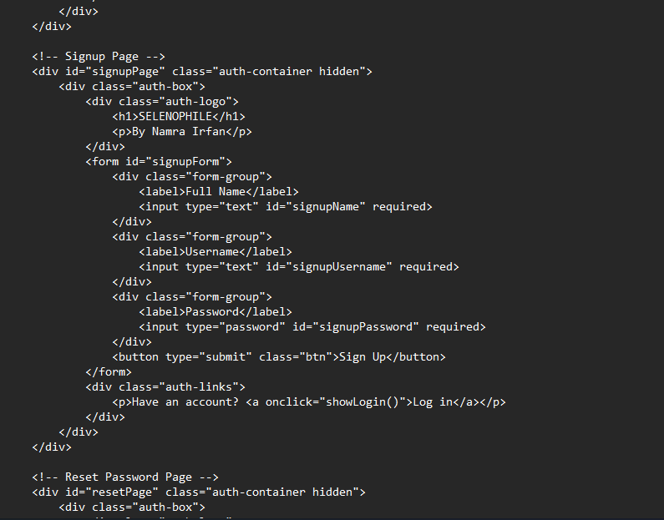
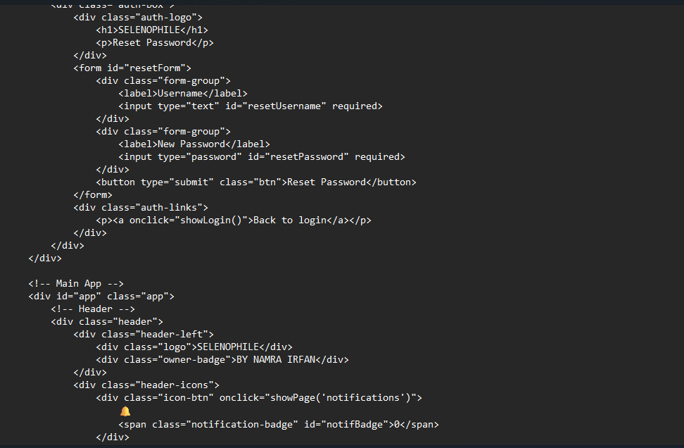
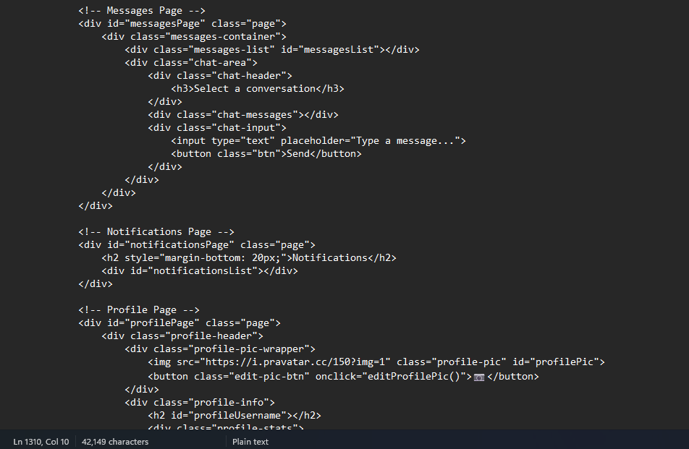

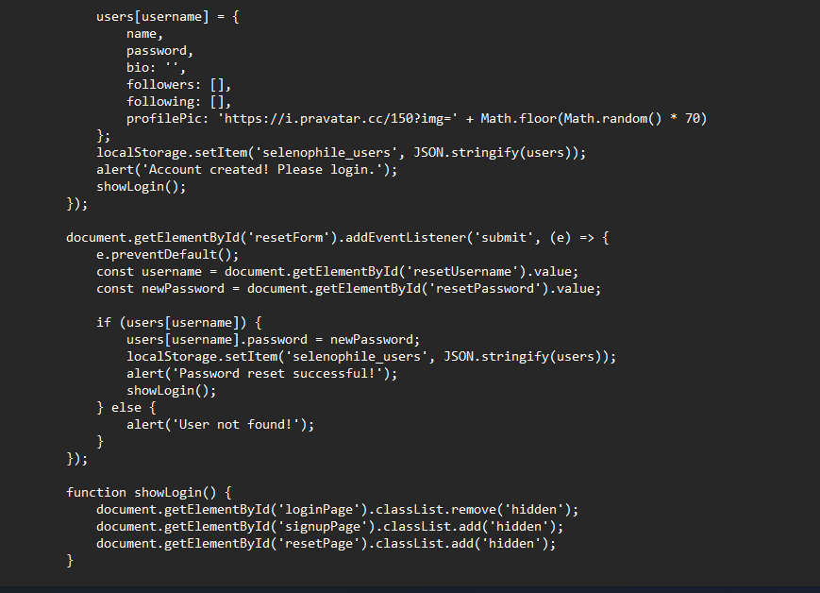
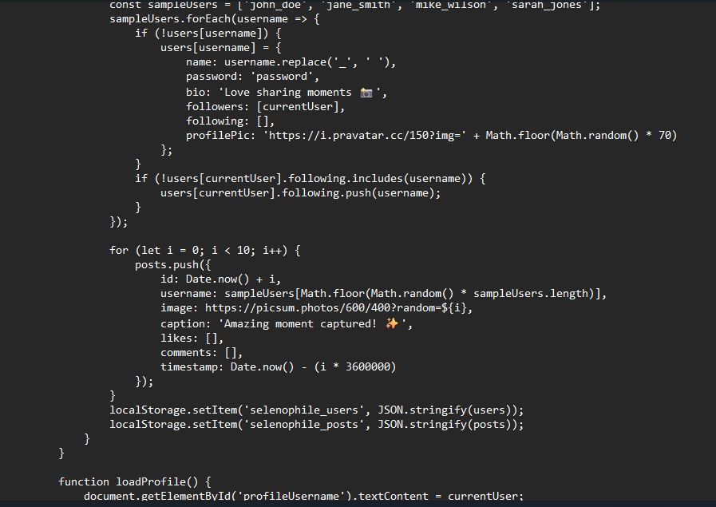
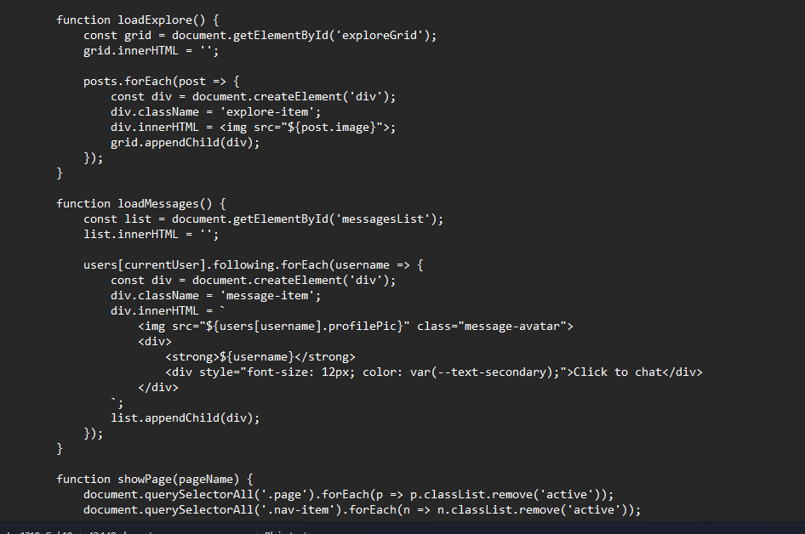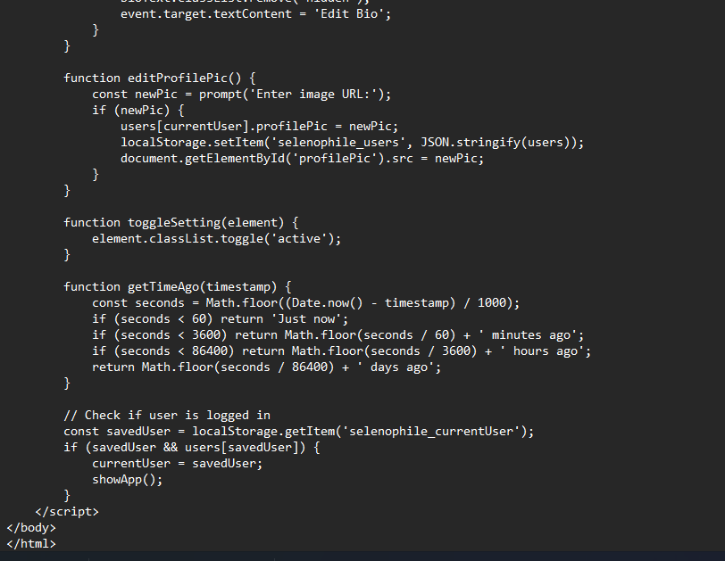
OUTPUT:
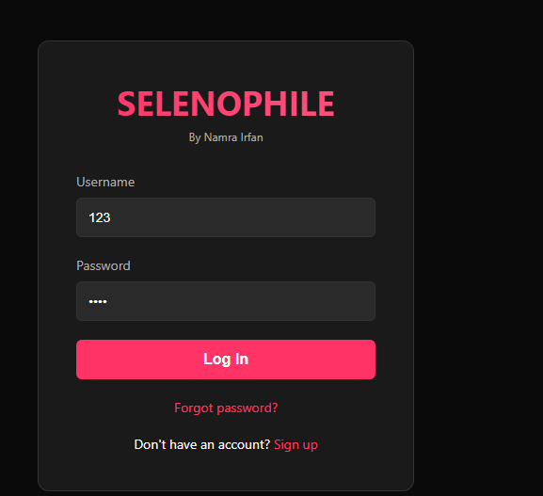
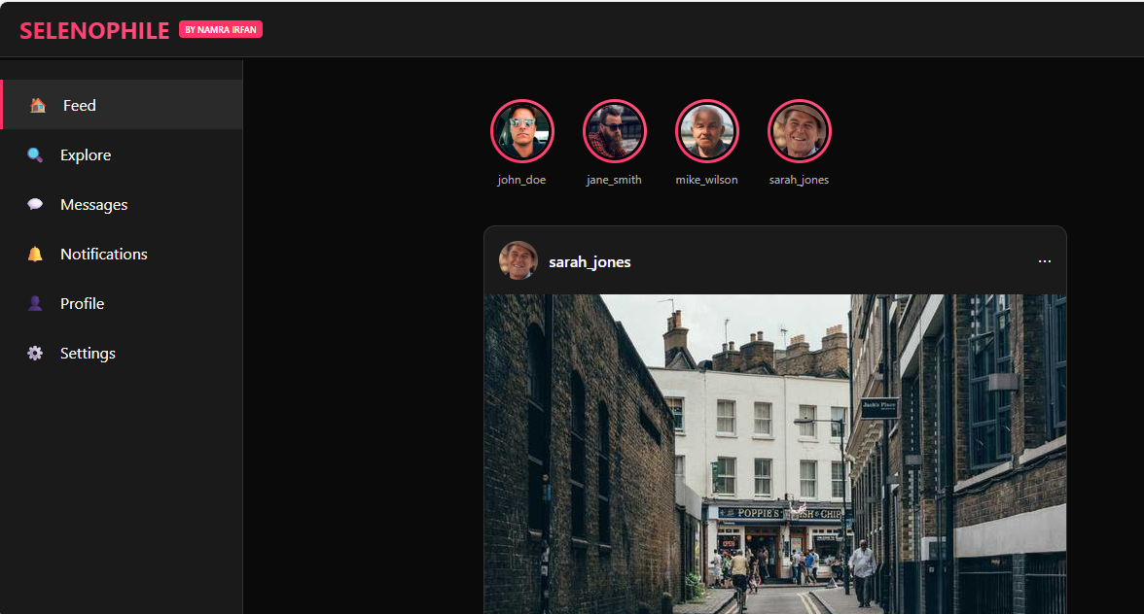

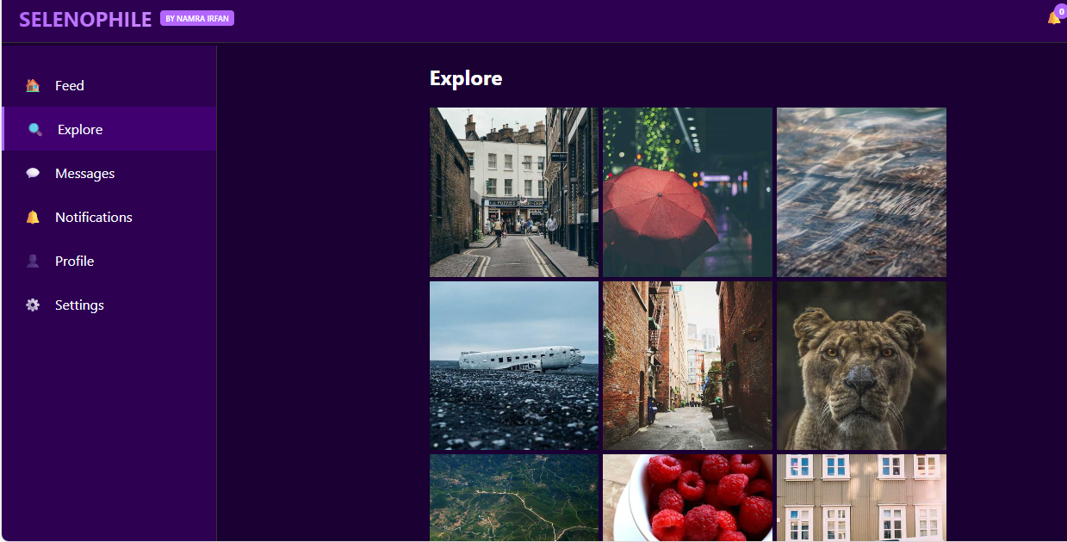
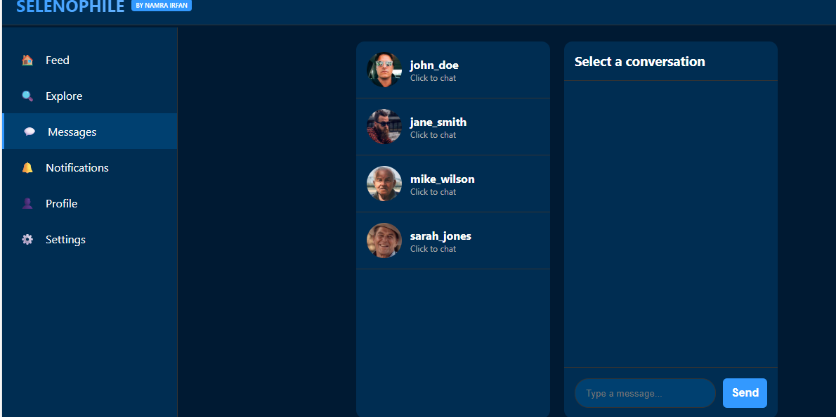
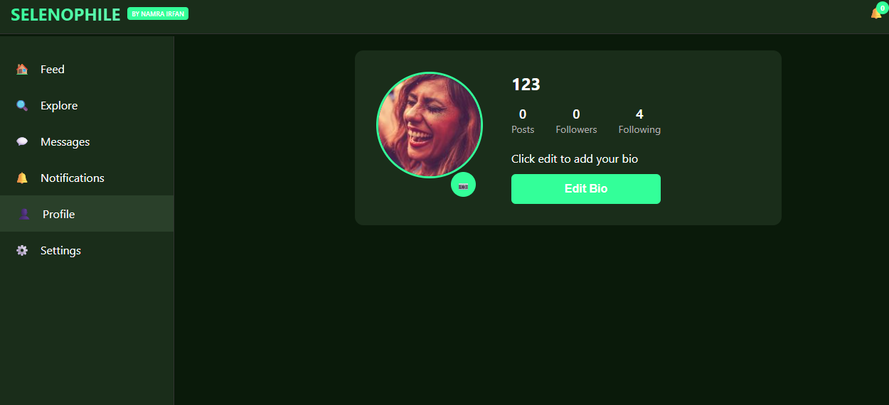
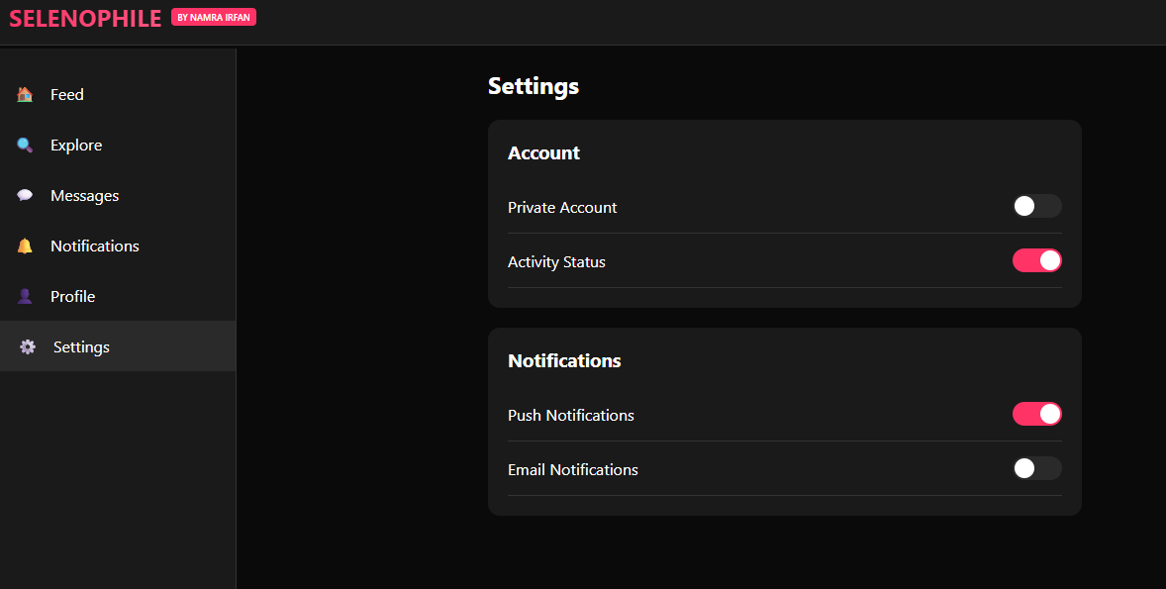
=======================================
THIS WAS ALL ABOUT MY PROJECT
APPS USED IN MAKING THIS PROJECT ARE:
- YOUTUBE
- GOOGLE CHROME
- GEMINI
- CLAUDE
- ETC….

